**Bubbles and Impact**

**Easter Sunday - 12th April**

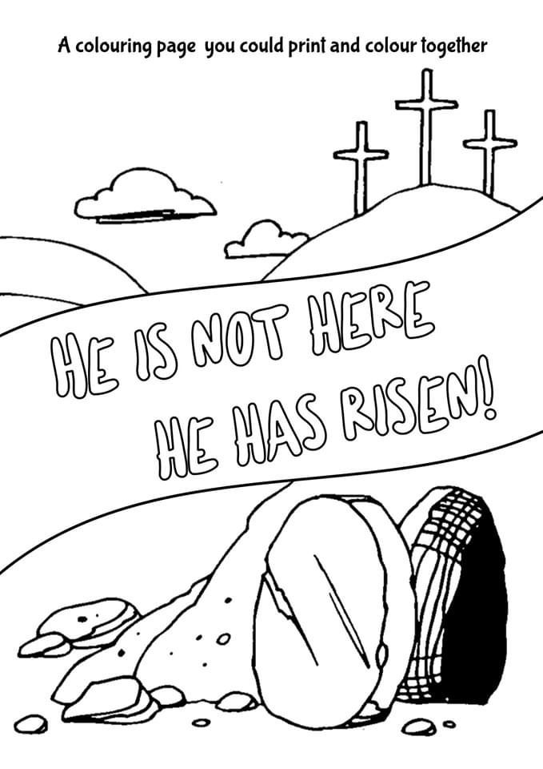

**5 – Prayer**

**Dear Father God,**

Thank you for the story of Easter and the empty tomb. Thank you that your plan did not end with death on the cross but with your resurrection and new life. Help me to share the good news of your death and resurrection with other people, just like Mary did. **Amen**

**3 – Questions**



1. Who was the first person to see that the stone had been rolled away from the entrance of the tomb.
2. What did Peter and John find in the tomb?
3. What had happened to Jesus?
4. Why was Mary so sad?
5. Why do you think Mary didn’t recognise Jesus?
6. When did she recognise who he was?
7. When Mary knew she’d seen Jesus what was the first thing she did?

**4 – Activity**



**Make your own Easter Garden -**

***You will need: Anything you have around the house.***

Gather items from your home, garden or from your daily walk to create your own Easter Garden together. You will need to select a stone to be in front of the tomb and roll away, a flowerpot or cup can make a good substitute for the tomb. You could do some junk modelling and use some items from your recycling or just build the whole thing from building blocks and toys. Once you have built your Easter garden, use any toy figures you have to act out the story of Easter morning together.

**2 - Story time**

**Let’s look at the Easter Story today…………**

<https://www.youtube.com/watch?v=HL8R158Ujp4>

Read the story of the empty tomb together in the bible. You will find it in :-

**John 20 vs 1-18**

**1 – Worship**



**Here are the links to some Kids songs that can help you praise God!**

**Risen**

This is a great song to dance round the living room too……..

<https://www.youtube.com/watch?v=JSdw0pblPqs>

**One way Jesus** <https://www.youtube.com/watch?v=KCLWPd5Yj9c&pbjreload=10>

