**Bubbles and Impact**

**Sunday 19thApril**

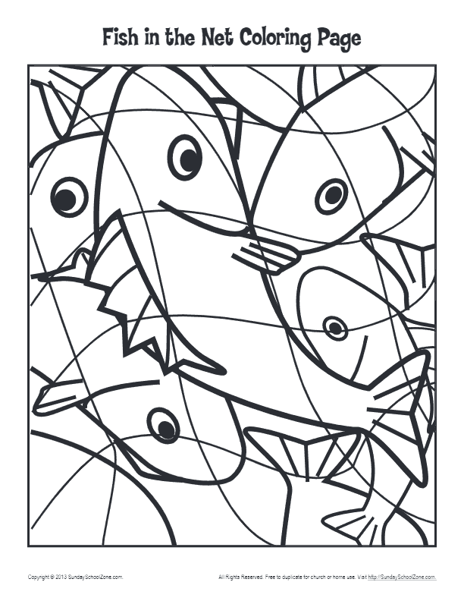

**5 – Prayer**

**Dear Father God,** We want to thank you today for all of the many wonderful things that you bless us with, just like the fish in today’s story there are so many of them! We are so grateful to know that when we sometimes mess up and do things that you wouldn’t like, you love us so much that you forgive us. Help us to live our lives for you this week. **Amen**

**3 – Questions**



1. What had Peter done that had let Jesus down?
2. How did Peter feel about it?
3. Do you ever feel that you’ve let Jesus down?
4. How did Jesus treat Peter and what did he ask him?
5. What did Jesus ask Peter to do? What do you think it means?

**4 – Activity**



**You will need some plain scrap paper, a pair of scissors and a pen**.

Cut out as many small fish as you can out of one or two pieces of paper. They need to big big enough for you to write on.

On each fish try and write a reason to be thankful to God for the amazing things that he has given to you.

**2 - Story time**

**Today’s story runs alongside the Easter story, of Jesus death and his resurrection. It looks at Jesus’ disciple, Peter.**

<https://www.youtube.com/watch?v=Ppb9bKX1r7k>

**You can read some of this story together in John Chapter 21.**

**1 – Worship**



**Here are the links to some Kids songs that can help you praise God!**

One way Jesus <https://www.youtube.com/watch?v=KCLWPd5Yj9c&pbjreload=10>

My lighthouse -

<https://youtu.be/OaW_4MWSE6I>

My God is so big –

<https://youtu.be/YUageJdwyPY>

