Bubbles and Impact
Sunday 26th April
4 – Activity

You will need some plain scrap paper, a pair of scissors and some pens.
Today we’d like you to make some paper doll chains, (full instructions are below if you need them.)
Once you’ve made the paper doll chain, think about which of your friends you could tell about Jesus. See if you can write their name on and decorate them too!

3 – Questions
- For how many days did Jesus stay on earth after his resurrection?
- Why did he appear to his disciples?
- Who did Jesus promise to send to his disciples to be their helper?
- What did Jesus ask the disciples to do?
- What happened to Jesus on his final day on earth? Where did he go?

2 - Story time

Today’s story is about what happened to Jesus after he came back to life.

https://www.youtube.com/watch?v=UcFw8pLBSIo
You can read this story together in Mark 16 vs 9-20
And Acts 1 vs 3-11 .
1 – Worship

Here are the links to some Kids songs that can help you praise God:
Ask, Seek, Knock:
https://www.youtube.com/watch?v=J3vXskhI1ig
My lighthouse -
https://youtu.be/OaW_4MWSE6I
My best friend -
https://www.youtube.com/watch?v=7JFjruVrrag

5 – Prayer
Dear Father God, We are so thankful for Jesus. We are thankful that he came to earth to show us how to live our lives and we are thankful that he died and came back to life so we may be forgiven. Help us to tell other people how wonderful Jesus is. Amen

Paper Doll Chain

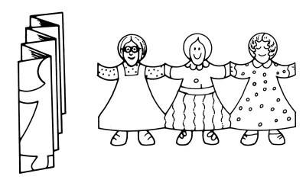

When you make a Paper Doll Chain, you will notice that all the dolls have the same shape. Even though these paper dolls are identical, you can color each one to look different.

How to Make a Paper Doll Chain

What You'll Need:
- Drawing Paper
- Blunt Scissors
- Pencil
- Markers
- Trims such as Ribbon, Yarn, or Fabric Scraps
- Craft Glue
1. Fanfold a piece of drawing paper evenly.
2. Draw your design for the paper dolls. Make sure the design touches both sides of the paper so the dolls "hold hands." Draw only one half of the doll since the other half will be across the top fold.
3. Cut out the doll pattern. Then decorate each doll with markers, or glue on trims such as ribbon, yarn, or fabric scraps.

Jesus ascends into heaven – Colouring Page

