**Bubbles and Impact**

**Palm Sunday - 5th April**

**5 – Prayer**

Dear Father God, We thank you that even though Jesus rode a donkey, he was a King! The King of Heaven. We thank you for Jesus and all the wonderful things that he has done. We want to ask you …………………………………………………………………………………………….. Amen.

**3 – Questions**



1. What did Jesus ask the disciples to do?
2. How did they find things?
3. Why do you think people threw coats on the floor and waved Palm branches when they saw Jesus?
4. What kind of things did the crowd shout when Jesus went by on the Donkey?
5. What do you think you would have shouted?

**4 – Activity / Craft**



**Leaf Hunt –**

Leaves play an important part in this story. How many different types of leaves can you find in your garden today? Can you identify them?

**Palm Leaf** - Can you print or draw your own palm leaf – template attached below? See what you can find to colour or collage it green.

**Maybe you can re listen to Blessed is the King and wave your palm branches.**

**2 - Story time**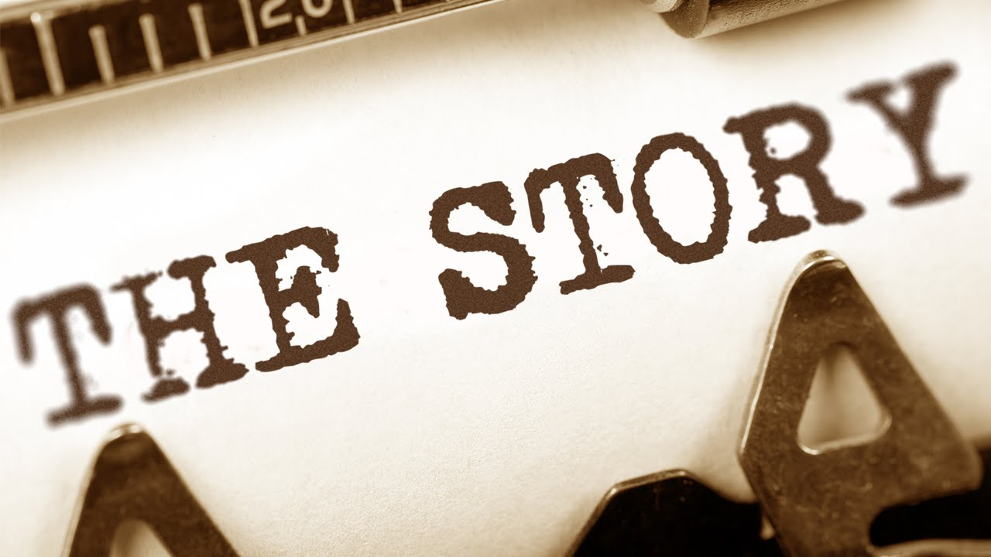

**Here’s a story about Jesus triumphal entry into Jersusalm, riding on a donkey.**

Can any of you remember joining in with this at breakfast church last year?

<https://www.youtube.com/watch?v=z-39h0xYqdE>

**Bubbles** - See if you can find this story in your childrens’ bible.

**Impact** - You can read this story in the Bible in Matthew 21 vs 1-11.

**1 – Worship**



**Here are the links to some Kids songs that can help you praise God!**

**My God is so big –**

<https://youtu.be/YUageJdwyPY>

**Every move I make -**

<https://www.youtube.com/watch?v=MPvnZILn6EY>

**Blessed is the King -**

<https://www.youtube.com/watch?v=NVulFFARMSs>

