Bubbles and Impact
Sunday 31st May, 2020

4 – Activity

You will need some paper or card, scissors and colouring pencils and glue.

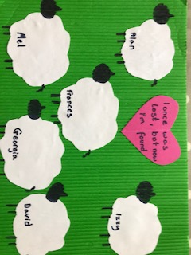

Step by step instructions are below!
3 – Questions
- Have you ever lost anything? What did you lose and how did it make you feel?
- In this story God is represented by a farmer. What does he have and what does he lose?
- What does the farmer do when he realises he’s lost a sheep? Why do you think he does that?
- How are we like the lost sheep?
- You’re so important to God that, like the lost sheep, he searches for us until he finds us. How does he do that?

1 – Worship

Here are the links to some Kids songs that can help you praise God:

My lighthouse -
https://youtu.be/OaW_4MWSE6I
I’m gonna jump up and down –
https://youtu.be/pPgUj29wCp0

2 - Story time

We’re still looking at the stories Jesus told, just like the grown ups!

Today we’re looking at the story of The Lost Sheep.
https://www.youtube.com/watch?v=_Ry2MaMyvGo
You can read this story together in Luke 15 vs 3-7.

5 – Prayer
Dear Father God, We thank you that you are like a good farmer. We thank you that when we have wandered off on our own path, doing our own thing, just like the sheep in this story, you come and find us. We thank you so much for your love. Amen
Amen
The Lost Sheep Craft

Get yourself a good background. You could draw one!

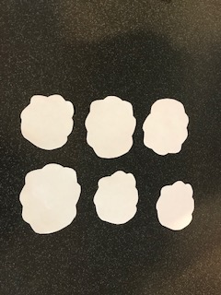 Cut out as many sheep as you can. Or use cotton wool.

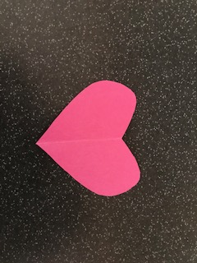 Draw or cut out a love heart.

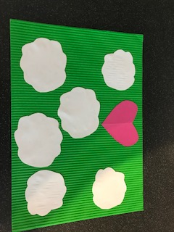 Stick your sheep and love heart onto the background.

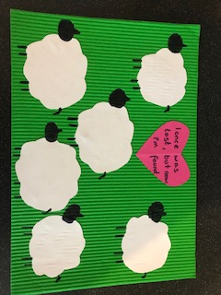 Draw heads and legs onto your sheep!

You can now write on the love heart a verse about God loving us, or use the famous line of a song that we’ve used – I once was lost, but now I’m found.

You may want to name your sheep, with people that you know God has already found, and who are part of his amazing family.

