**Bubbles and Impact**

**Sunday 3rd May, 2020**

**3 – Questions**



1. How many son’s did the Father in this story have?
2. What did the younger son ask for?
3. What did the younger son do with all that he had been given?
4. How do you think this would have made the Father feel if he knew? Why?
5. What did the younger son realise eventually?
6. How did the Father accept the son?
7. God loves you like this. How does that information make you feel?

**4 – Craft Activity**

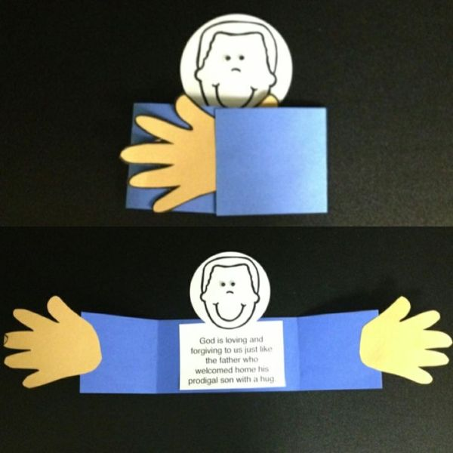

**You’ll need some card / paper, scissors, pens and some glue.**

Today’s suggested craft is to make a Father outstrecting his arms, to remind us how much we are loved by God, who is our heavenly Father.

Full instructions on how to make today’s craft activity are on the sheet below.

**2 - Story time**

**We’re going to be looking at the stories Jesus told, just like the grown ups!**

Today’s story is The Prodigal Son. You can watch it here –

<https://www.youtube.com/watch?v=DJgROx4wFKM>

This story is in **Luke 15 vs 11 - 32**

**1 – Worship**



**Here are the links to some Kids songs that can help you praise God:**

My best friend -

<https://www.youtube.com/watch?v=7JFjruVrrag>

My God is so big –

<https://youtu.be/YUageJdwyPY>

God’s love is Big

<https://www.bing.com/videos/search?q=god+love+is+big+lyrics&docid=608037424550317356&mid=45FDBF3AE34BB>

**5 – Prayer**

**Dear Father God,** I want to thank you that you are a good, food father. That you love us, no matter what we do, and that you are always willing to forgive us. Help us to be good children. We want to ask for ………………………………………………………………. **Amen**

**Today’s Craft Instructions – The Father with outstrectched arms**

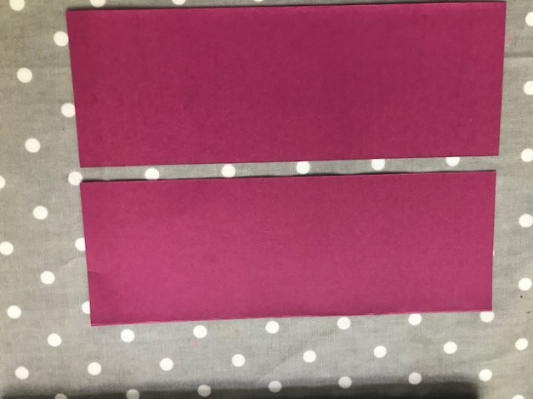

**Cut a piece of A4 Card in half lengthways**

**Fold the card into 3 pieces.**

**Draw a rectange with a circle on the top. Cut out.**

**Draw round your hands, cut out.**

**Stick on as shown.**

**Write on the memory verse.**

**Draw a face on, using whatever you have.**

**Display as a reminder that God loves you!**

