**Bubbles and Impact**

**Sunday 21st June, 2020**

**2 - Story time**

**We’re still looking at the stories Jesus told, just like the grown ups!**

Today we’re looking at The Parable of the Workers in the Vineyard.

<https://vimeo.com/64413019>

You can read this story together **in Matthew 20 vs 1-16.**

**1 – Worship**



**Here are the links to some Kids songs that can help you praise God:**

My God is so big –

<https://youtu.be/YUageJdwyPY>

One way Jesus - <https://www.youtube.com/watch?v=KCLWPd5Yj9c&pbjreload=10>

**5 – Prayer**

**Dear Father God,** We thank you for all of the wonderful stories that Jesus told. We thank you that today’s story shows us that you are generous and that you treat all of us equally, because you love all of us equally, and that your love is not dependent on what we do for you. Today I want to thank you for ………………………………………………….. **Amen**

**4 – Activity**

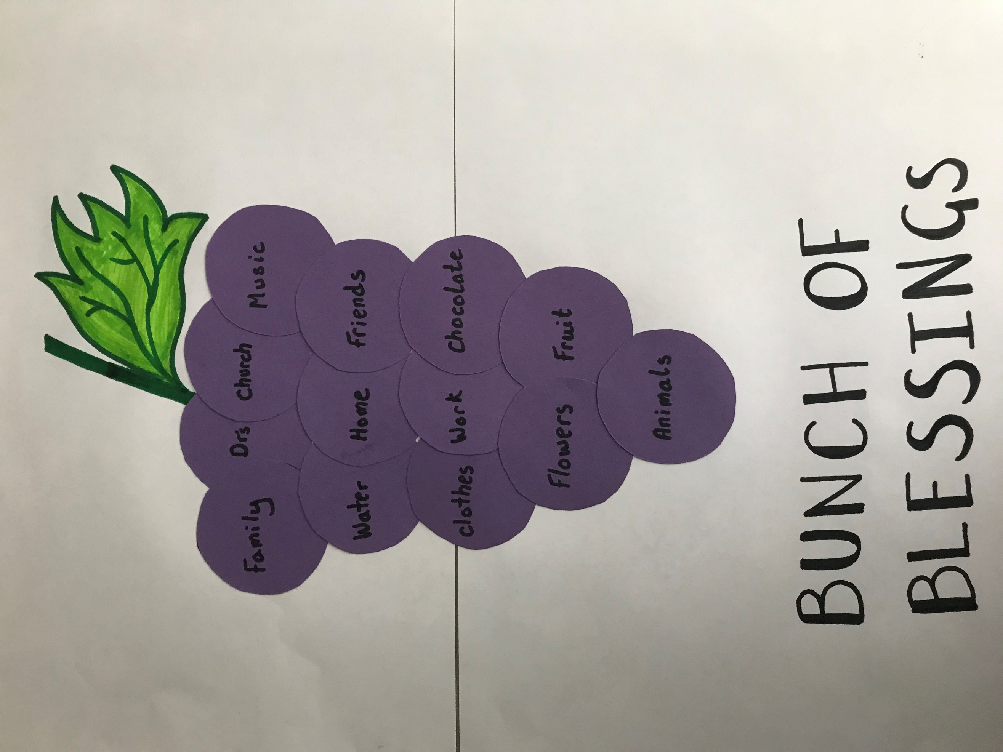

**See if you can make, draw or print out and colour the template below, to make your own bunch of grapes.**

On each grape see if you can think and write one of the many blessings that God has given us, that remind us what a generous God he is. And how he loves us all the same.

**3 – Questions**



1. What did the farmer in this story grow?
2. When he hired men to work for him the morning, what did he promise them?
3. Why did he have to go and hire more people?
4. How much did he pay everyone?
5. Why did the people he hired first complain? Do you think what the farmer did was fair?
6. What does this story tell us about God’s generosity?

**Bunch of Blessings**

