Bubbles and Impact
Sunday 19th July, 2020

2 - Story time
Today we’re going to have a bit of a look at who Jesus family were, and what he did growing up.

https://www.youtube.com/watch?v=irTmdgAOPfA

Read together Luke 2 vs 52 and Mark 6 vs 3

1 – Worship

Here are the links to some Kids songs that can help you praise God:

My lighthouse -
https://youtu.be/OaW_4MWSE6I
I’m gonna jump up and down –
https://youtu.be/pPgUj29wCp0
My God is so big –
https://youtu.be/YUageJdwyPY

4 – Activity
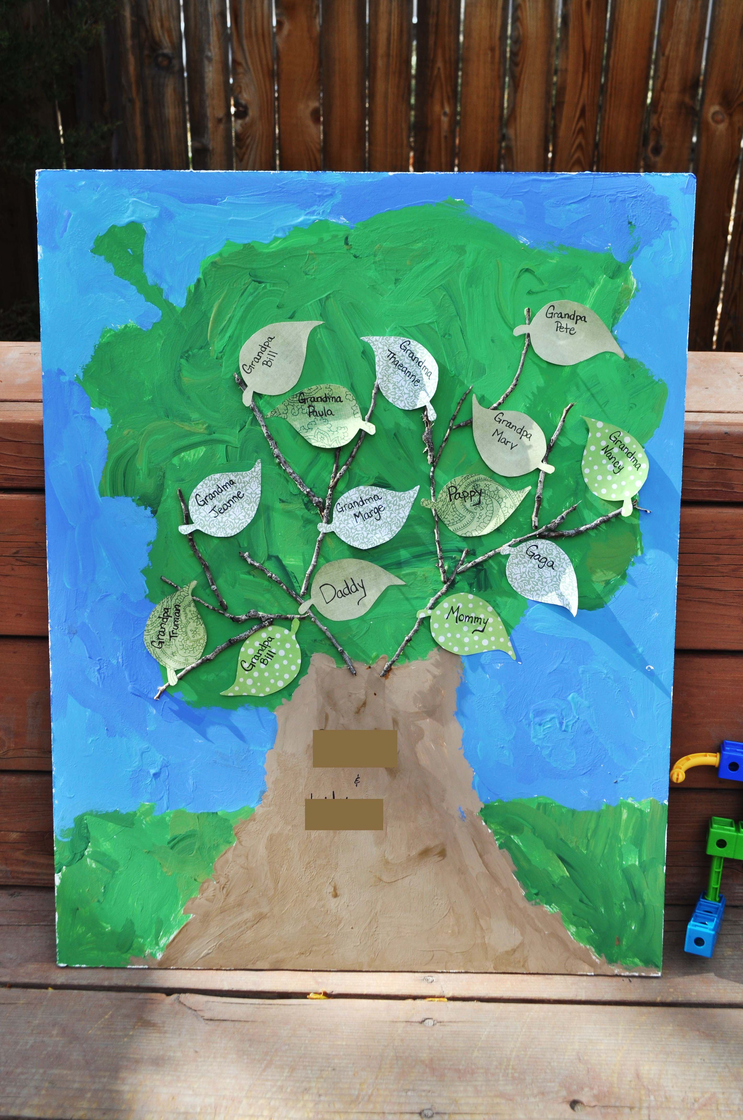

Coloured or White paper.
Pens/crayons/paints.
Scissors and Glue
Today we’d like you to create a family tree.
Try and create a tree, using whatever you have available to you. When you have drawn/painted/ collaged your tree, cut out leaves and see how many people in your family you can fit onto your tree.
While you’re doing it, think of all the ways in which your family members love, care and support you in different ways.

5 – Prayer
Dear Father God, We thank you for our families. We thank you that each family is made of unique family members and that you love each one of them. Amen
3 – Questions
- What can you remember about Jesus parents? (Think about the Christmas story!)
- Do you know what Joseph’s job was? (Mark 6 vs 3)
- Which of Jesus brothers and sisters do we know about? (Mark 6 vs 3)
- Do we know of any of his other relatives? (Luke 1 and 2)
- In what ways are our families a sign of God’s blessing to us? How do they love, help and support us?
- Who in your family also helps support you in learning about Jesus?

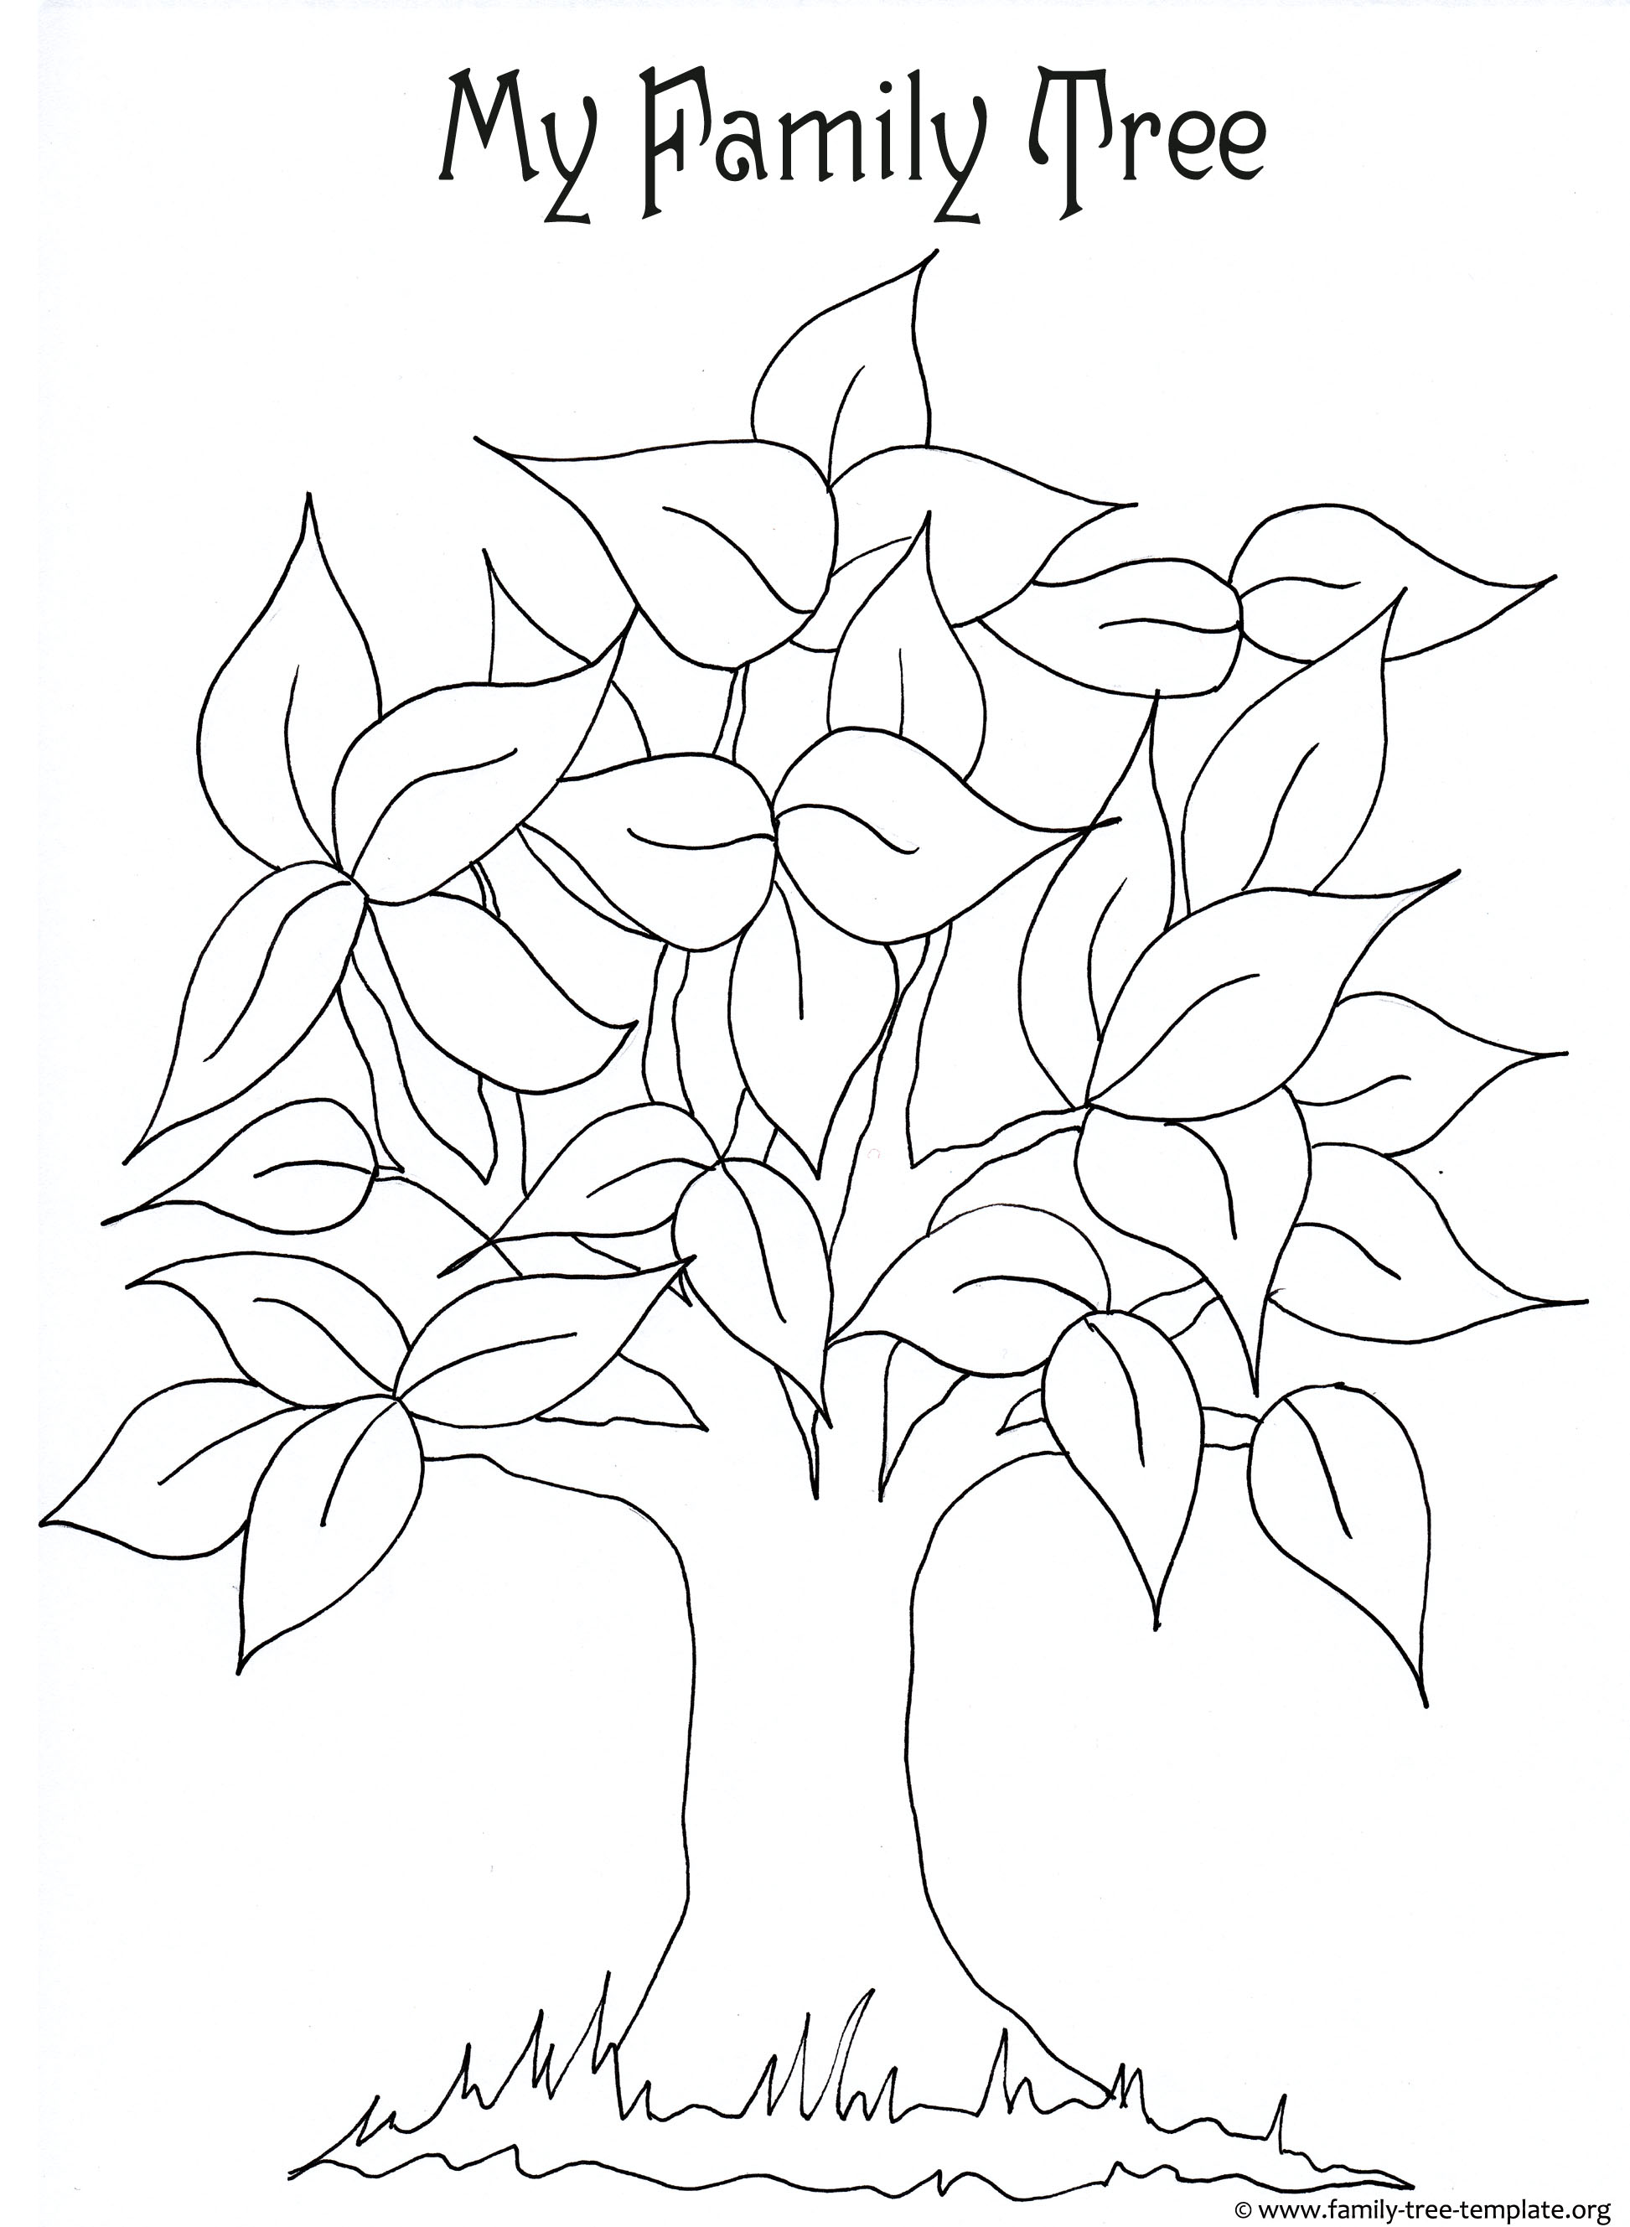
Can you write on the name of each leaf a member of your family, and how they are related to you?

Let’s thank God for our families, and how they support and love us as we grow!
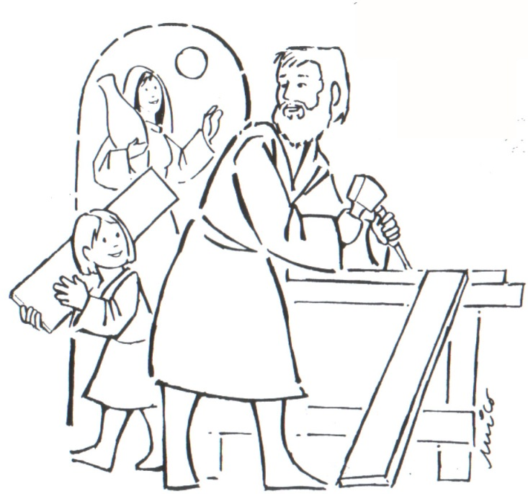

Jesus was the Son of ……………………………………………….…
His earthly parents were ……………………………………………
His brothers were called…………………………………………….
His cousin was called …………………………………………………

