**Bubbles and Impact**

**Sunday 26th July, 2020**

**2 - Story time**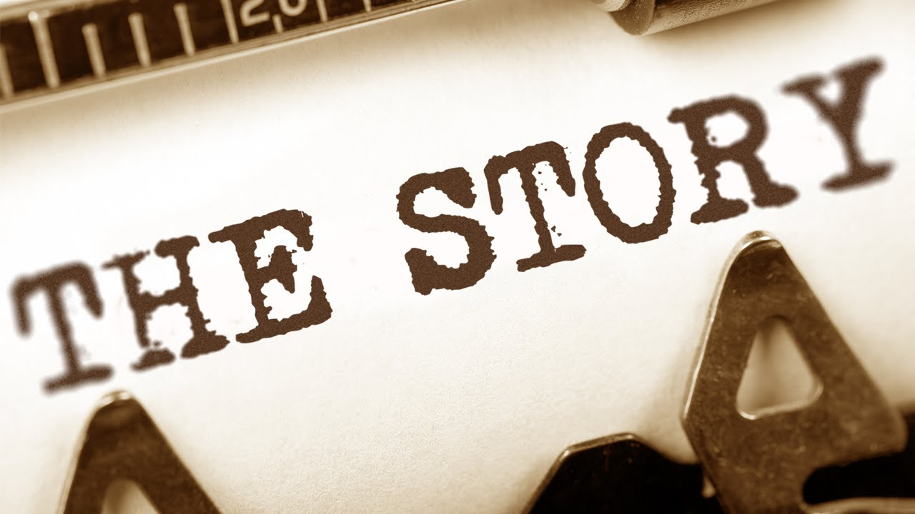

**Here’s a short story about Jesus being baptised for you to enjoy:**

<https://www.youtube.com/watch?v=NuedVFB8-7Y>

You can read this story together in the Bible in **Mark 1 vs 1-11.**

**1 – Worship**



**Here are the links to some Kids songs that can help you praise God:**

My lighthouse -

<https://youtu.be/OaW_4MWSE6I>

I’m gonna jump up and down –

<https://youtu.be/pPgUj29wCp0>

My God is so big –

<https://youtu.be/YUageJdwyPY>

**5 – Prayer**

**Dear Father God,** We thank you for Jesus. We thank you that he was your Son and that he was always obedient to you. Help us to learn to be obedient to you and to know your Holy Spirit with us as we walk through life. **Amen**

**4 – Activity**

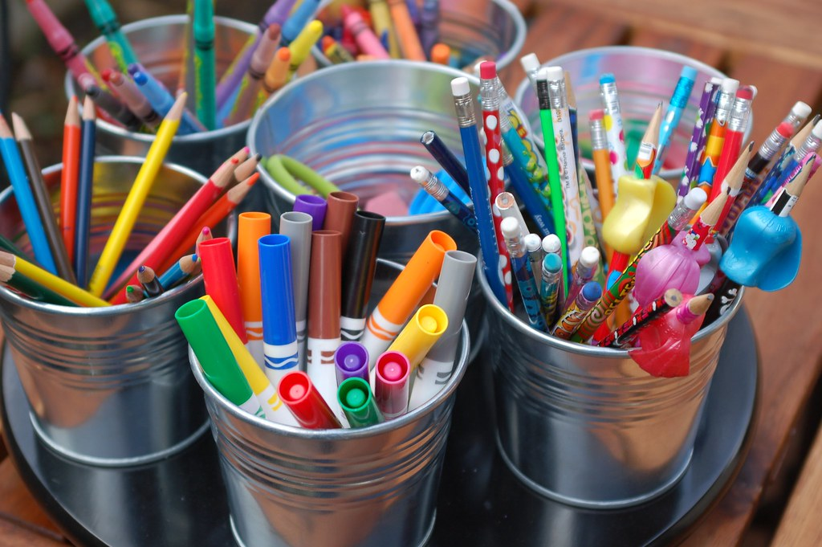

**You will need White Paper and some scissors.**

**Option 1 –** Print or draw the dove template below. Cut round the outline. Fold paper like a fan to make the wings / tail and thread them through where marked.

**Option 2** – See if you can follow the instructions to make and origami dove!

**3 – Questions**



1. Have you or anyone in your family ever been to a baptism?
2. What happens at a baptism?
3. Who baptised Jesus?
4. Why did people need to be baptised?
5. Why was Jesus baptised?
6. What happened after Jesus was baptised?

